BLOOD IS MEDICINE
Averett University
October 22, 2021

LIVING WITH SICKLE CELL DISEASE. Video from Nari’k Page, a young man from Virginia who has Sickle Cell Disease. The American Red Cross collects blood for transfusion to adults and children with the disease. There is not a readily available cure for Sickle Cell Disease.

WHAT IS SICKLE CELL TRAIT? WHAT IS SICKLE CELL DISEASE? American Red Cross Medical Director, Dr. Yvette Miller; (23 minute video)
Sickle Cell trait is inherited. An individual with Sickle Cell trait received one Sickle Cell gene (an abnormal gene) and one normal gene from their parents. Carrying the trait does not mean that an individual has Sickle Cell Disease. It is estimated that 1 in 13 Black or African-American babies in the U.S. is born with Sickle Cell trait. Today, many individuals are unaware if they carry the trait.

WHY SHOULD I KNOW MY SICKLE CELL TRAIT STATUS? The Red Cross offers Sickle Cell trait testing, at no fee, when an individual donates blood. Knowledge is power. When you know your Sickle Cell trait status, you are informed and can prevent another human being from having Sickle Cell Disease. Individuals with the Sickle Cell trait can donate blood. Health experts recommend that individuals be aware of their status and consult their medical provider on what having the Sickle Cell Trait means for them.

ABOUT SICKLE CELL DISEASE. Sickle Cell Disease is the most common genetic blood disease in the U.S. where it primarily affects people of African ancestry (Black and African-American individuals).
- Patients with Sickle Cell disease may rely on regular blood transfusions throughout their lives to help prevent complications, such as organ and tissue damage, leg ulcers, pain, and strokes.
- A single patient can require up to 100 units of blood each year to treat complications from the disease. Many may need to receive blood transfusions throughout their lives.
- Did you know there are more than 600 known blood antigens? Some are unique to specific racial and ethnic groups, making a diverse blood supply a necessity. Because Sickle Cell Disease is a genetic disorder, patients need closely matched blood from people of the same race and ethnicity to avoid complications from transfusion. Therefore, African-Americans have a unique gift and ability to help children and adults with Sickle Cell Disease by donating blood.
- Greater Richmond, Virginia is ranked as one of the top 9 cities in the United States with a high demand for blood for transfusion to individuals battling Sickle Cell. Other cities ranked in the top 9 include: Atlanta, Baltimore, Philadelphia, Columbia, South Carolina; Birmingham, Oakland, California; St. Louis, Missouri; and Detroit. VCUHealth in Richmond treats individuals across the Commonwealth of Virginia who are suffering from Sickle Cell.

DONATE NOW
Find a Blood Drive Near You
Monetarily

SOCIAL MEDIA
Educate and encourage your friends.

4 FAMOUS INDIVIDUALS SUFFERING WITH SICKLE CELL DISEASE
Larenz Tate, Actor
Love Jones (Movie)

Tionne ‘T-Boz’ Watkins, Singer & Actor
TLC (Singing Group)

Tiki Barber, Professional Athlete
Former NFL Football Player

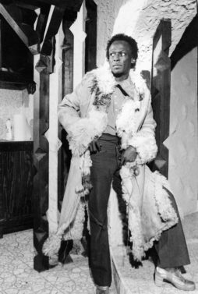
Miles Davis, Musician/Trumpeter
The most influential and acclaimed figures in the history of jazz music.

