Junie B. Jones and her Big Fat Mouth
Activities
By: Heather Smith

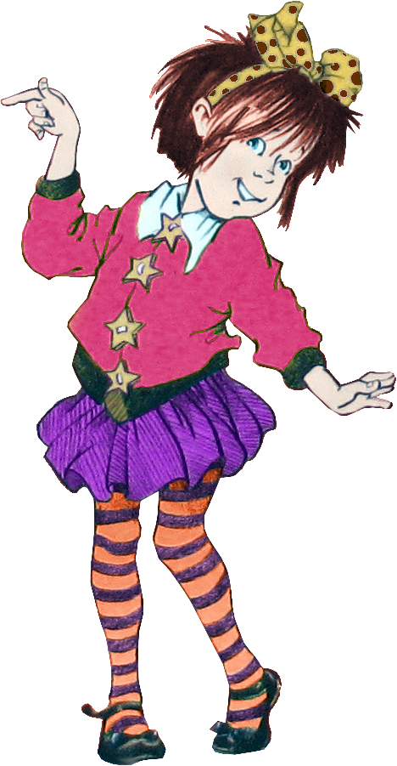

This packet was created by a student/pre-service teacher at Averett University. It was created in fulfillment of course objectives, and its goal is to encourage reading and appreciation of the theatre. Materials created by the class are not endorsed by or affiliated with Barbara Park, the Junie B. Jones series, or its publishers.

Junie B. Jones and Her Big Fat Mouth Plot Summary
Junie B. Jones is having a rough week at school. First she gets into trouble with her teacher, and then she gets into a fight with Jim. She gets put into punishment for the comments she makes to Jim and has to sit alone in time out. At recess she gets in trouble with the janitor because she tries to eat candy that was on the ground. After recess class nine is visited by a police officer and a dentist. When the class finds out that it is job day on Monday, Junie B. opens her big mouth and says she has the best job idea ever! Even at home she gets into trouble by making her brother cry, but she saves the day by finding his missing pacifier. At school on Monday Junie B. finally reveals her dream job: she wants to be a janitor, because they save the day at school.

About the Author
Barbara Park was born in Mount Holley, New Jersey. Her most famous work is the Junie B. Jones series of books. This book series is focused on young readers and consists of 30 different stories. The Junie B. series of stories has sold over 55 million copies in North America. Barbara Park won many awards for the Junie B. series, including the Kid’s Choice Award and Parent’s Choice Award. The book series centers around Junie B. Jones, who is a feisty, funny, and lively child, and how her outspoken personality often gets her in trouble at school and at home.

BEFORE WE READ

What do you already know about Junie B. Jones?

What are some of the objects you see on the cover?

Looking at the cover, what do you predict this story will be about?

What are you curious to find out while reading this book?

After We Read

What event do you remember most from the story? Why?

What event in the story did you not like? Why?

If you could change one thing in the story, what would it be?

Job Day
Imagine that you are in Junie B. Jones’s class during job day and can see what each of the characters is wearing for their chosen job. In the spaces below, draw pictures of each of the kid’s outfit that they wore on Job Day at school.
Junie B. |  |  | Roger |  | Jim
William |  |  | Grace |  | Charlotte

Chapter 1: Punishment

As you read the first chapter of Junie B. Jones and her Big Fat Mouth, answer the following questions.

What are the rules in Mrs.’ Classroom?
1._____________________________________________
2._____________________________________________
3._____________________________________________

What is a punishment in Room Nine?
____________________________________________________________________________________________

Why did the janitor yell at Junie B. at recess?

Draw a picture of what happened.

Junie B. Jones Noun, Verb, Adjective Word Game
Using the words provided from the story, determine if each word is a
Verb: an action word
Noun: a person, place, or thing
Adjective: a word that describes a person, place, or thing

Verb | Noun | Adjective

Boy | Girl | Run
Jump | Paper | Laugh
Eat | School | Cop
Dentist | Teacher | Janitor
Green | Blue | Red

*Note to teacher: make the above table available to students or, as a variation, print and cut out the squares to distribute to individuals or groups.

Was Junie B. Right or Wrong?
A MORAL decision is when you have to decide if you think something is RIGHT or if something is WRONG. The answer to a moral decision is not a FACT but comes from your judgment. Different people may have different answers to moral decisions because we all have different opinions.
Read the following situations from the Junie B. Jones story that we read and make a moral decision about them: Do you think they were morally RIGHT or WRONG, or are you not sure?
Situation | Right | Not Sure | Wrong
I made a fist at him. “How’d you like a knuckle sandwich, you big fat Jim?” I shouted right back.

“I didn’t mean to frighten you, sis,” he said. “But I spotted a bunch of dirty candy in the grass. And I was going to clean it up when I finished painting.” He looked serious at me. “Don’t you ever eat anything you find on the ground. Do you hear? Not ever.”

Then I ran speedy fast around the room. And I butted that mean Jim in the stomach with my head.

“Goonie,” he said. “Goonie B. Jones. There’s no such job like that in the whole entire universe!”

“Daddy’s home! Daddy’s home! Hurray! Hurray!” I yelled. Then I ran to him. And he picked me up. And I gave him my most biggest hug

“HEY! LOOK! IT’S THE PACIFIER!” I shouted. “I FOUND THE PACIFIER! IT WAS HIDING UNDER THE ROCKING CHAIR!” Then I hurried to pick it up. And I gave it to Mother. Her face got relief on it. “Thank goodness,” she said.

“Hey! I’ve got a bathrobe just like that, Jim!” I said very friendly. “It’s not a bathrobe, dummy,” he said. “I’m a kung fu karate guy.” “Jim is a kung fu karate guy,” I said to Grace. “Except for he just got out of the bathtub.”

Room Nine started laughing very much. And it was the mean kind. “SHE WANTS TO BE A JANITOR!” they yelled. Then they pointed at my brown pants. And they called me the name of stupid.

“And guess what else?” I said to Room Nine. “Me and Janitor are bestest friends. And sometimes he calls me the nickname of sis!”

Now that we have finished the Junie B. Jones story, imagine that you are in class with Junie B. Jones on Job Day. What job would you pick, and why?
_____________________________________________________________________________________
____________________________________________________________________________________
____________________________________________________________________________________
____________________________________________________________________________________
_____________________________________________________________________________________

What would you wear?
_____________________________________________________________________________________
____________________________________________________________________________________
____________________________________________________________________________________
____________________________________________________________________________________
_____________________________________________________________________________________

Draw a picture of yourself dressed up for that job.

Dear Parent or Guardian,
Junie B. Jones and her Big Fat Mouth has both educational and entertainment value. In terms of entertainment, there are many funny things that Junie B. does and has done to her that are sure to entertain your child as they read the story. In terms of educational value, the activities that we will be doing in class will enhance your child’s writing skills, creativity, and reading skills.
I would like to mention that next year there will be a Junie B. Jones musical produced at The Prizery in South Boston. I hope you will take your child to this play because it will emphasize and enhance their understanding of the adventures of Junie B. Jones.

Sincerely,
Heather Smith

