Junie B. Jones Resource Packet
By: Christen Seamster

This packet was created by a student/pre-service teacher at Averett University. It was created in fulfillment of course objectives, and its goal is to encourage reading and appreciation of the theatre. Materials created by the class are not endorsed by or affiliated with Barbara Park, the Junie B. Jones series, or its publishers.

About Junie B. Jones, First Grader (at last!): The book Junie B. Jones First Grader (at last!) is a wonderful book for young children to read. The spunky Junie B. Jones is ready to take on first grade (or so she thinks!). Junie B. soon learns that first grade is not the same as kindergarten, and she must make all new friends. Also, Junie B. Jones needs glasses! She is very nervous about making all new friends and the fact that no one else in her class wears glasses. However, by the end of the book, Junie B. learns that first grade is actually pretty cool and glasses are super cool too!
About the Author: Barbara Park is the amazing author of the Junie B. Jones series. She originally went to school to be a high school teacher but ended up finding a love for writing. She also found a knack for thinking like a child to create the wonderful character Junie B. Jones. She was a consistent New York Times #1 bestselling author, and her books are read by children all over the world! If you would like to learn more about the author, you can visit this website: https://www.scholastic.com/teachers/authors/barbara-park/
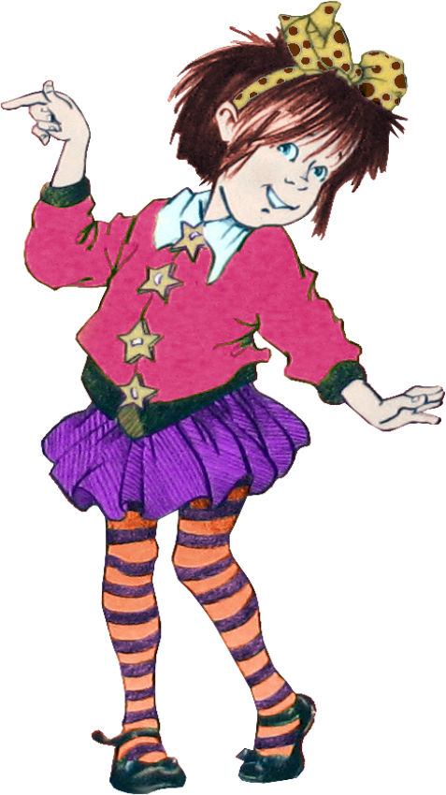

Directions for Activities
(in order)
Roll-a-Story: Junie B. Jones Packet:
Have the students get into groups of 3-6. Give them each a die to roll. The students will roll to receive a character, problem, and setting. Then, with the given writing space, the students must create a story using the elements they were given and create a resolution to the problems.

The Five Senses:
The students will draw a line from the book quotation to the correct sense portrayed by the image. Then, they write a short story about using all five senses.

Types of Sentences: Junie B. Jones Style:
This is a whole-class activity that involves a projector. Each student will get a paper, scissors, and glue. They are to cut out the types of sentences and cut the flaps to make a booklet. Then they glue the spine part into a journal or notebook they have. Then, they cut out the quotes and glue them under the correct flap (the teacher will be completing this activity with them on the projector).

Make Your Own Junie B. Jones Character:
The students are to create and draw their own Junie B. Jones character and write a short story about them.

Junie B. Jones and the Stand Up Sit Down Game:
This is a whole-class activity where the teacher will call out one of the words in the chart, and the students will stand if it is a proper noun, and sit if it is a common noun.

My School Journal:
This is an individual activity. Each student can receive a packet to fill out over a course of three days. Each day, the student is given a prompt to write about and an area to draw a picture.

Roll-a-Story

Die Roll | Setting | Character | Problem
 | Junie B.’s House | Lucille | finds out they need glasses
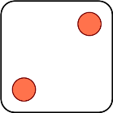 | The Nurse’s Office | Junie B. Jones | argues over who will bring what to the talent show
 | On the Bus | Camille and Chenille | is going to tattle tale on their best friend
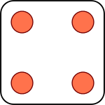 | In Room 1 | Tattle Tale May | is going to be late for the bus
 | At the Eye Doctor | Mr. Scary | forgets their talent show item at home
 | At Recess | Herb | someone else is in their seat on the bus

Write your story below and add a resolution to the problem:

Story #1: ____________________________________________________________________________________________________________________________________________________________________________________________________________________________________________________________________________________________________________________________________________________________

Story #2: ____________________________________________________________________________________________________________________________________________________________________________________________________________________________________________________________________________________________________________________________________________________________

Story #3: ____________________________________________________________________________________________________________________________________________________________________________________________________________________________________________________________________________________________________________________________________________________________

Story #4: ____________________________________________________________________________________________________________________________________________________________________________________________________________________________________________________________________________________________________________________________________________________________

Story #5: ____________________________________________________________________________________________________________________________________________________________________________________________________________________________________________________________________________________________________________________________________________________________

Story #6: ____________________________________________________________________________________________________________________________________________________________________________________________________________________________________________________________________________________________________________________________________________________________

The Five Senses
The five senses are sight, smell, hearing, taste, and touch. We all use our five senses every day and they help us answer important questions we may have. For example, if we want to wear something warm on a cold day, we may feel our coats or sweaters to see which is the thickest. On the next page, there are quotations from several Junie B. Jones books where she is using her five senses. Draw a line matching the quote to the picture of which sense is being used.

1) “He showed me some hard green things.
This Photo by Unknown Author is licensed under CC BY-ND
And some hard yellow things. And some
hard red things. He said those were the fruits.
I put my tongue on a green one. ‘Yuck!’ I said.
‘Bluck!”
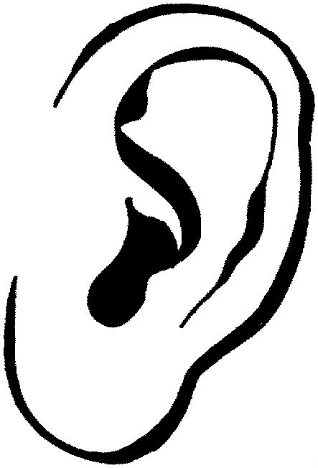
This Photo by Unknown Author is licensed under CC BY-SA-NC
- ) “The bus made a big roar. Then a big puff
of black smelly smoke came out the back end
of it. It’s called bus breath, I think.”
- ) “Then the brakes made that loud, screechy
noise again. I covered my ears so it couldn’t
get inside my head.”

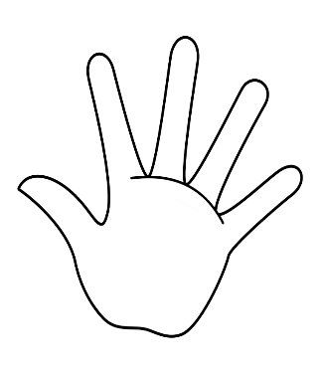
- ) “And guess what? I saw three more
This Photo by Unknown Author is licensed under CC BY-SA
smudgies and a smeary. After I was done,
I sat down in the chair again. Mrs.
Weller said I need glasses.”

5.) “And then people started squishing me
real tight. And so I pushed them away. And
they pushed me right back.”

Write a story where you use all five senses:

___________________________________________________________________________________________________________________________________________________________________________________________________________________________________________________________________________________________________________________________________________________________________________________________________________________________________________________________________________________________________________________________________________________________________________________________________________________________________________________________________________________________________________________________________________________________________________________________________________________________________________________________________________________________________________________________________________

Types of Sentences: Junie B. Jones Style
Command
Statement
Question
Exclamation
Sentence Examples from Junie B. Jones: First Grader (at last!) Cut out the sentences and glue them under the correct sentence type.
1. “My room is named Room One.”
2. “Then I hugged and hugged that girl!”
3. “I jumped up and down and all around.”
4. “What kind of an old friend looks like a dumb notebook?”
5. “‘You shouldn’t talk while the teacher is talking, Junie Jones!’”
6. “‘I want you to read these words to yourselves,’”
7. “‘Which word are you drawing?’”
8. “‘Don’t you want to show me your drawing?’”

Make Your Own Junie B. Jones Character

My Character

My Character’s Name: ________________________________
My Character’s Age:___________________
My Character’s Best Friend:___________________________
On the lines below, write about your character! Tell all of their likes, dislikes, and hobbies, or how they would fit into the wonderful world of Junie B. Jones!
______________________________________________________________________________________________________________________________________________________________________________________________________________________________________________________________________________________________________________________________________________________________________________________________________________________________________________________________________________________________________________________________________________________________________________________________________________________________________________________________________________________________________________________________________________________________________________________________________________________________________
Junie B. Jones and the Stand-Up-Sit-Down Game
Junie B. Jones | Boy
Herb | Pencil
Glasses | Bobbi Jean Piper
Frown | Finger
Eyes | Lucille
Mrs. Weller | Chicken
My School Journal

Name: ____________
My School Journal Entry #1
In the book, Junie B. Jones First Grader (at last!), Junie B.’s first journal entry is about her first day at school. On the lines below, write the thoughts you had on the first day of school.
___________________,
__________________________________________________________________________________________________________________________________________________________________________________________________________________________________________________________________________________________________________________________________________________________________________________________________________________________________________________________________________________________________________________________________________
My School Journal Entry #2
Junie B. learns she needs glasses later on in the book. She is worried about getting glasses because none of her other classmates wear them. If you were in class with Junie B., what would you say to her to make her feel better?
___________________,
________________________________________________________________________________________________________________________________________________________________________________________________________________________________________________________________________________________________________________________________________________________________________________________________________________________________________________________________________________
My School Journal Entry #3
Junie B.’s last journal entry was her discussing show and tell in her class. Have you ever had show and tell in your class? If you have, what did you bring? If you haven’t, what would you bring if you did?
___________________,
________________________________________________________________________________________________________________________________________________________________________________________________________________________________________________________________________________________________________________________________________________________________________________________________________________________________________________________________________________

Dear Parents/Guardians,
Hello, my name is Christen Seamster and I am a pre-service teacher. Thank you for taking the time to read over this letter. In this letter I would like to outline how the Junie B. Jones book series can help your child succeed and soar in their academic careers.
As some of you may already be familiar with the lovable character Junie B. Jones, then you know how she is a spunky young girl with a creative way of compiling her sentences. She is also involved in many crazy adventures that are just as entertaining for adults as they are for children. In these amazing stories, Junie B. teaches children all across the world very important lessons. The biggest lesson of all is the importance of writing. Writing is something all children need to be able to do if they want to receive good grades through school and also be successful in life. Writing allows us to use our imaginations, convey our ideas and opinions, and let our feelings out when we are unable to say them. Junie B. teaches children that it is a great idea to keep a journal and write out all of these thoughts that go through our minds.
In one particular book, First Grader (at last!), Junie B. struggles to start a new grade and make new friends while also dealing with the fact that she needs glasses. Throughout the story, Junie B. writes down her feelings and concerns to try and help her cope with the new problems she is facing, and in the end Junie B. learns that there is nothing wrong with making new friends and that glasses are actually super cool! So, I hope this letter and the activities I have created will teach and entertain your child in some way, and they will continue to grow a love for reading, writing, and school as they continue on their own wonderful, magical, and amazing journey! Also, I would like to mention the play coming to the Prizery in the Spring. The play is going to be based on the Junie B. Jones series and I highly recommend taking your child to see it!
Best Wishes,
Christen Seamster

