Junie B. Jones and Some Sneaky Peeky Spying
Education Resource Packet

Brittanny Jennings
Averett University

This packet was created by a student/pre-service teacher at Averett University. It was created in fulfillment of course objectives, and its goal is to encourage reading and appreciation of the theatre. Materials created by the class are not endorsed by or affiliated with Barbara Park, the Junie B. Jones series, or its publishers.

Plot Summary:
Junie B. Jones is now in kindergarten and is sure she is the best spier in the world. Junie B. Jones believes she is the best spier in the world because she has sneaky feet and her nose does not make a whistling sound when breathing. Junie B. Jones uses her spying techniques and spies on her grandpa, baby brother Ollie, and her teacher, Mrs. Junie B’s mother attempts to put a stop to her spying; however, Junie B’s curiosity leads her to spy on Mrs. at the grocery store, and she misunderstands what she observes. Junie B. Jones goes to school keeping a secret until she cannot hold the secret in any longer. The secret leads Junie B. Jones into the principal’s office with a result of getting herself into trouble.

About the Author:
Barbara Park wrote Junie B. Jones and Some Sneaky Peeky Spying based on doing some sneaky peeky spying of her own. Barbara Park use to hide in the hamper when she was little. Barbara Park is best known as the New York Times bestselling author of the Junie B. Jones series. The Junie B. Jones series consists of a humorous kindergartener who learns morals and lessons by getting into trouble. Before becoming a bestselling author, Park’s first intention was to become a history and political science teacher. After receiving her secondary education degree, she found her true passion, which was to become a writer.

Dear Parents,

My name is Brittanny Jennings, and I am a pre-service teacher attending Averett University. It is my goal not only to provide all students with an educationally challenging classroom, but also to help your child build character, understand writing structure, and learn new vocabulary through the Junie B. Jones book series. Focusing on Junie B. Jones and Some Sneaky Peeky Spying, I will use this book to focus on building good character traits. Displaying good character traits is valuable in the classroom to build morals and self-respect. In this book, your son or daughter will learn about the concept of spying and how spying can lead to getting into trouble. I have crafted several interactive activities to help students connect with the character of Junie B. Jones.
In addition to the Junie B. Jones education resource packet, your child will have an opportunity to see the character of Junie B. Jones come to life. In the spring of 2020, The Prizery in South Boston, Virginia will stage a production of Junie B. Jones: The Musical. The production will be a great experience for you and your child to connect what was learned through the resource packet to the character on stage.

With appreciation,
Ms. Jennings
Directions:
Junie B. Jones admires her kindergarten teacher, Mrs.
Junie B. Jones thinks that teachers are not “regular people” and that teachers are perfect because they set the examples for students. Out of curiosity, Junie B. Jones attempts to spy on Mrs. to see what she does outside of school. It is important to connect with your teacher to develop the student-teacher relationship.
From the following list of questions, select three to ask your teacher. Afterward, write three facts about yourself so your teacher can find what you have in common.
Question 2:
What kinds of activities do you like to do?
Question 1:
What is your favorite food?

Question 4:
Why did you want to become a teacher?
Question 3:
What is your favorite color?

Question 6:
What is your favorite book to read?
Question 5:
What are your classroom rules?

Question number ______
Answer: _____________________________________________________
_____________________________________________________
_____________________________________________________
_____________________________________________________

Question number ______
Answer: _____________________________________________________
_____________________________________________________
_____________________________________________________
_____________________________________________________

Question number ______
Answer: _____________________________________________________
_____________________________________________________
_____________________________________________________
_____________________________________________________

Three facts about me!

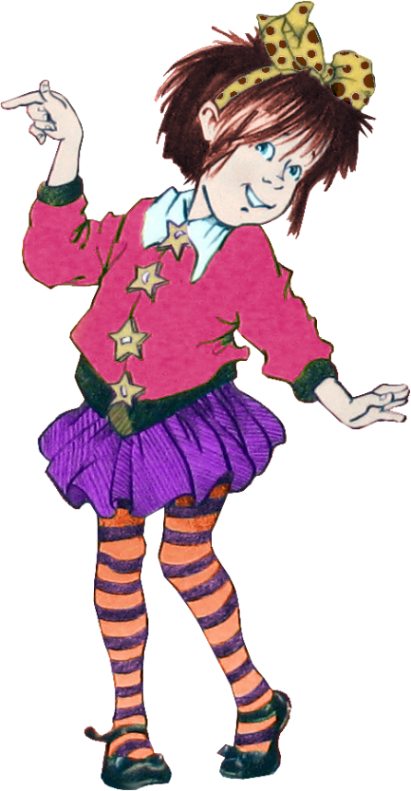

Sneaky Peeky Spying & Order of Events

“
Arrange the events in the order they happened from numbers 1 through 5.
- Junie B. Jones tip toes in her brother’s room and scares baby Ollie by blowing in his face and shouting “Wake Up!”
_________

- Junie B. Joes hides in the hamper and scares Grampa Miller _________

- Junie B. Jones tells Mrs. about the time Mother burned the cookies _________

- Junie B. Jones asks Lucille where Mrs. lives _________

- Junie B. is curious about what type of house Mrs. has and asks Mrs. if she has a rich or regular house _________
Predict what will happen next. Do you think Junie B. will find out where Mrs. Lives? Why or why not?
_____________________________________________________
_____________________________________________________
_____________________________________________________
Draw a picture of what you think Mrs. house looks like:

The following words are key components to understanding and comprehending stories:
Character: People in the story

Setting: Where the story takes place

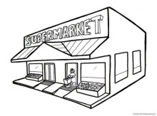
Plot: What happens in the story (beginning,
middle, and end)

Conflict: The problem in the story

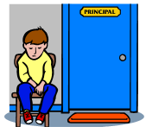
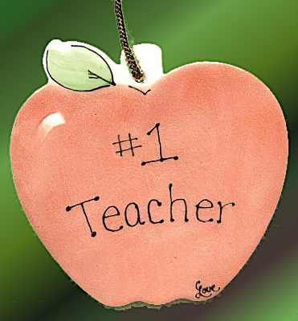
Resolution: How the problem is solved

Theme: The message in the story

Using the story elements above, fill out the anchor chart and draw a picture describing each anchor on the following pages.
Character:
__________
__________
__________

Setting:
__________
__________
__________

Plot:
__________
__________
__________
Conflict:
__________
__________
__________

Resolution:
__________
__________
__________

Theme:
__________
__________
__________

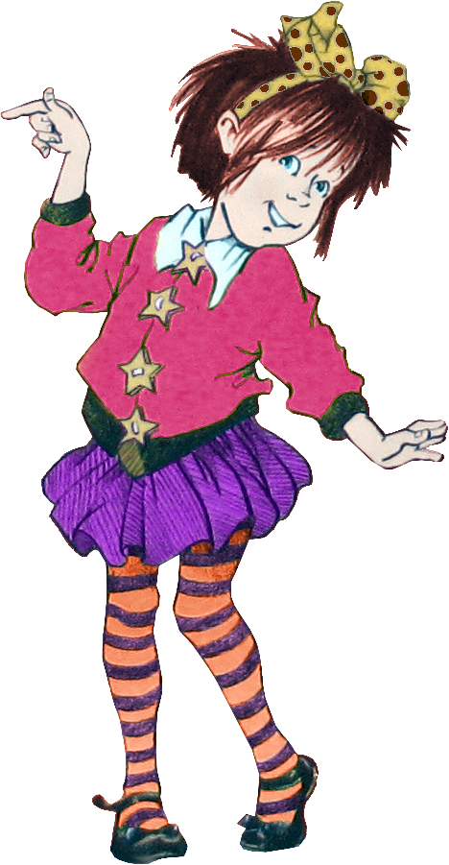
Junie B. Jones is ecstatic about Grandparents Day. Everyone in her class is bringing some sort of food item to help celebrate Grandparents Day. Think about your favorite recipe. Ask your teacher, parent, or guardian for help.

My favorite recipe is called:
----------------------------------------------

The necessary ingredients are:
------------------------------------------------------------------------------------------------------------------------------------------------------------------------------------------------------------------------------------------------------------------------------------

The steps for making it are:
----------------------------------------------------------------------------------------------------------------------------------------------------------------------------------------------------------------------------------------------------------------------------------------------------------------------------------------------------------------------------------------------------------------------------------------------------------------------------------------------------------------------------------------------------------------------------------------------------------------------------------------------------------------------------------------------------------------------------------------------------------------
