Junie B. Jones and
Some Sneaky Peeky Spying
Tonya Dix
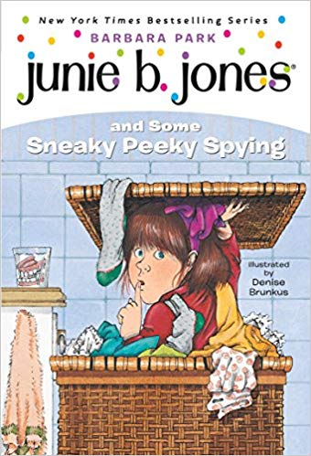

This packet was created by a student/pre-service teacher at Averett University. It was created in fulfillment of course objectives, and its goal is to encourage reading and appreciation of the theatre. Materials created by the class are not endorsed by or affiliated with Barbara Park, the Junie B. Jones series, or its publishers.

Summary:
Junie B. Jones is a feisty little kindergartener who has a problem with spying. She spies on her parents, grandpa, and now her teacher! She sees her teacher in the grocery store across the aisle and watches her eat a grape out of the bag that she didn’t pay for. Junie is very frazzled because she was taught that stealing was bad, and she couldn’t believe that her very own “Mrs.” was stealing. She decided not to tell anyone because she didn’t want to get in trouble for spying. The next day she went to school and she tried and tried to keep her secret until one of her classmates told her that her head would explode if she didn’t tell anyone. She ended up going to the principal and told him everything. Mrs. is called to the office, and they discuss why she was eating the grapes and explained to Junie that it is wrong to steal and spy.

About the Author:
Barbara Park was an exceptional writer. Unfortunately, she passed away November 15, 2013 from ovarian cancer. When she was in college, she thought she would be a history and political science teacher, but she found out that writing was what she loved. Her Junie B. Jones series has won many awards. Park was a very passionate woman who supported many people and causes, and her legacy still lives on today through the countless stories she’s written.

Junie B. Jones… Sneaky Peeky Spying Trashball
Teachers: You’ll need a clean trashcan and two small foam balls. Divide the students into two teams. Each team will stand in a line, one student behind the other, all facing the trashcan. The teacher will read off comprehension questions about the book aloud to the students, and whichever team answers correctly first gets to take the first shot. If they make the shot, they get 10 points. If they miss, then the opposing team gets to shoot, and both teams keep shooting until someone makes it; that shot will be only worth 5 points. The game will continue until all questions are completed, and whichever team gets the most points will be rewarded with free time, homework passes, treats, etc.
Examples of questions:
- What grade is Junie B. Jones in?
- What does the B in her name stand for?
- Where did Junie B. Jones hide when she spied on her Grandpa?
- How did Junie wake up her little brother?
- Why did Junie get in trouble at the grocery store in the past?
- What did she think Mrs. was doing in the grocery store?
- What did Junie think would happen if she kept the secret?

Different Settings

Teacher: Discuss what happens and important details at the different settings in the book, including the classroom, grocery store, and the principal’s office. Tell the student to draw each setting from the book in its assigned box, and discuss what is going on in that particular setting. At the end have them write about their favorite part of the story.

Classroom:
Draw a picture of what you think the classroom
and the students look like, and then write about
something that happens in this place.

_________________________________________
________________________
_________________________________________
________________________
_________________________________________
________________________
_______________________________________
Grocery Store:
Draw a picture of grocery store, and then write about
something that happens in this place.

_________________________________________
________________________
_________________________________________
________________________
_________________________________________
________________________

Principal’s Office:
Draw a picture of the principal’s
office and then write about
something that happens in this place.

_________________________________________
________________________
_________________________________________
________________________
_________________________________________
CONTEXT CLUES
In Some Sneaky Peeky Spying, Junie B. Jones uses a lot of funny words! There are words we may not know, and to find out the meaning, we can use context clues. Context clues are hints and words in the sentence that help you figure out the word you do not know.
Directions: Pick the word from the word bank below that best completes the sentence and then, using context clues, write what that word means.
Curiosity Punishment Scuffle Idea Apology

- Junie tried her best not to care about where Mrs. lived but her curiosity got
the best of her and she decided to find out

Definition: Curiosity means wanting to know more about something.

- Junie and Jim got into a ______________ on the playground and she tore his
shirt.

Definition: ______________________________________

- Junie had to write Jim an __________________ for tearing his shirt.

Definition: _______________________________________

- When Junie got home from school, she received _____________
for fighting with Jim.
Definition: ____________________________________________________

- Junie spent all night thinking of an _______________ to get out of trouble.
Definition: ____________________________________________________
NOUNS AND VERBS
Junie B. Jones says a lot of funny words that are nouns and verbs!
Don’t forget that NOUNS are people, places or things
and
VERBS are action words, things you can do.

Directions: Color all the boxes with nouns RED and all the boxes with verbs BLUE!

Mrs. | Spy | Hide
Holler | Grampa Miller | Tippy-Toe
School | Play Ground | Huffy
Room Nine | Shout | Grocery Store
Bake | Mother | Eat
How to Behave in the Classroom
Good VS Bad

Junie B. Jones learns many lessons about good and bad behavior in the classroom.
Directions: Write a sentence about why each example below represents good or bad classroom behavior.
A student raising her hand to ask questions
____________________________________________
____________________________________________
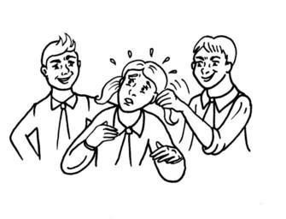
A boy pulling his classmate’s hair
____________________________________________
____________________________________________

Classmates fighting over a teddy bear during free time
____________________________________________
____________________________________________

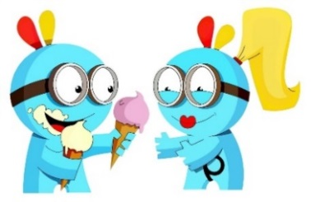
The boy sharing his ice cream with the girl during lunch
____________________________________________
____________________________________________
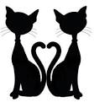
Similarities
Junie B. Jones is a very funny and quirky kindergartener, and you are more than likely very similar to her! Similarities are when things are the same or are alike.

Directions: Think about Junie B. Jones and how you and she are similar.
Write about these similarities in complete sentences below.

Junie B. Jones YOU
Junie B. Jones is in Kindergarten. | I am in Kindergarten.

Dear Parents and Guardians,
Hello, my name is Tonya Dix, and I am a pre-service teacher at Averett University. I am sending this letter home to enlighten you on the great educational value of Junie B. Jones and Some Sneaky Peeky Spying and the rest of the series. I encourage you to sit down and take time and read with the student and discuss all the different elements and lessons the story has to offer. The story offers real-life lessons your child will go through, and it makes them very relatable.
The experiences in the book are normal for a young child to go through, and the book series is a good way to help your child understand the differences between good and bad by making the lessons fun. Junie B.’s adventures introduce your child to these topics and make learning and life lessons entertaining and more memorable. I also encourage you to take your student to see Junie B. Jones: The Musical at the Prizery in 2020; this would be a great experience for students to see a book they love and relate to come to life.
Thank you so much!
Tonya Dix

Thank you all for giving my resource packet a look, and I hope you can find use for it in your classroom!
This Photo by Unknown Author is licensed under CC BY-NC-ND

Don’t forget about JUNIE B. JONES: THE MUSICAL!

