Junie B. Jones and The Stupid Smelly Bus Resource Packet
By: Sydney Edwards

This packet was created by a student/pre-service teacher at Averett University. It was created in fulfillment of course objectives, and its goal is to encourage reading and appreciation of the theatre. Materials created by the class are not endorsed by or affiliated with Barbara Park, the Junie B. Jones series, or its publishers.

About the Author:
Barbara Park
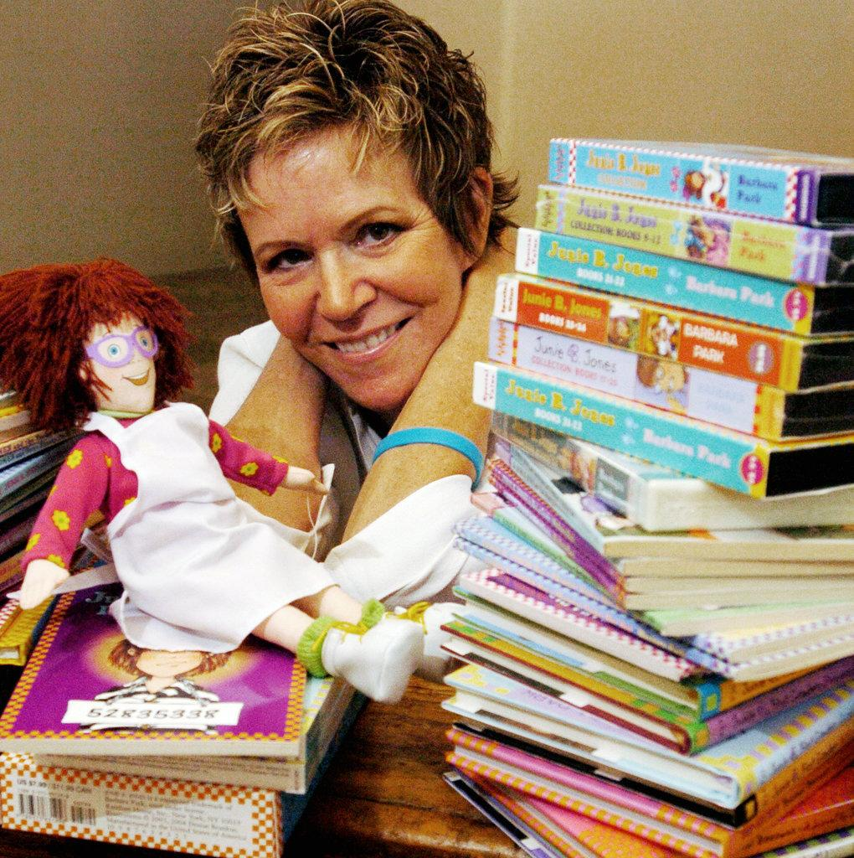
Barbara Park (April 21, 1947 - November 15, 2013) was born and raised in Mt. Holly, NJ. She originally intended to become a history and political science high school teacher, but she quickly realized that she was called to write. As a result of her realization, she created the hilarious, beloved Junie B. Jones book series. This book series has won over 40 children’s book awards, sold over 60 million copies in the United States alone, and has been a consistent New York Times bestseller. Unfortunately, Park passed due to ovarian cancer on November 15, 2013. However, her legacy still lives on through her boisterous character, Junie B Jones.

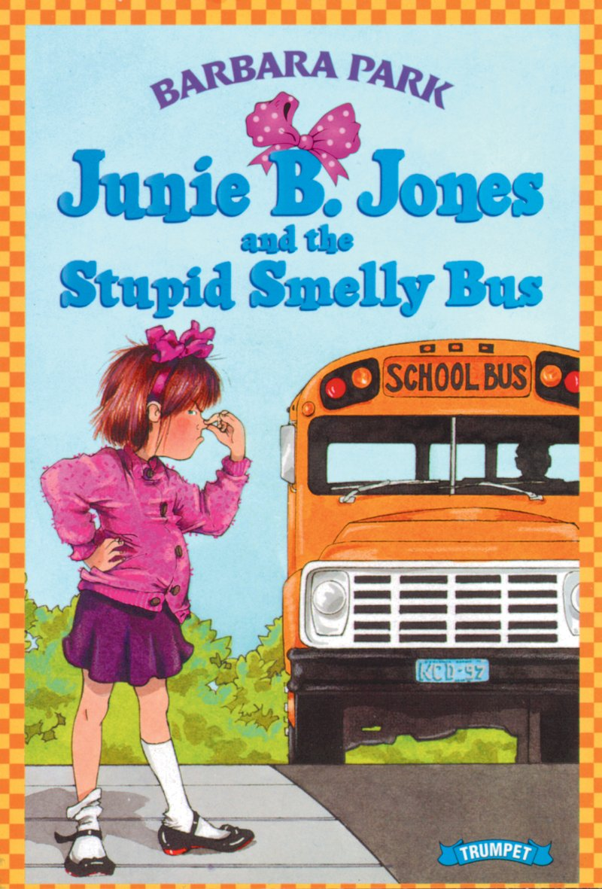
Summary:
Junie B. Jones and the Stupid Smelly Bus

In this book, Junie B. is extremely nervous about attending school and riding the bus for the first time. She manages to successfully finish her first day and bus ride; however, she doesn’t want to ride the bus home because of a rumor that a student told her. As a result, she tries to hide and avoid riding the bus home, but she becomes even more nervous because she is lost and alone, and in the end, she learns an important lesson about what happens when you try to hide from your problems.

Create Your Own “Stupid Smelly Bus”

Directions: Design your very own bus using the diagram below and fill in adjectives that describe your designs in the blanks.

Definition of adjective: A word or phrase that is used to describe a noun
Examples of adjectives from Junie B. Jones and the Stupid Smelly Bus :

- “Then the bus began getting very noisy and hot inside.”
- “It was very big inside”
- “I hate it in this stupid smelly bus.”

1._____ 3._____ 5._____ 7._____ 9._____

2._____ 4._____ 6._____ 8._____ 10._____

STOP

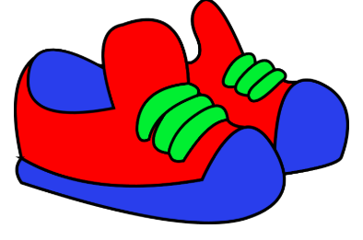
Put Yourself in the Character’s Shoes

Directions: Draw a picture in the box below showing what you would have done to solve Junie B.’s problem in the book.

Directions: Write complete sentences about what you what have done to solve Junie B.’s problem in the book.

If I were Junie B. in this story, I would have___________________________________________________

_______________________________________________________

_______________________________________

_______________________________________

_______________________________________________________

Directions: Work in your groups, talk, and write out what the elements of Junie B. Jones and the Stupid Smelly Bus are.

Elements of a Story

WHO?  - Main Characters:  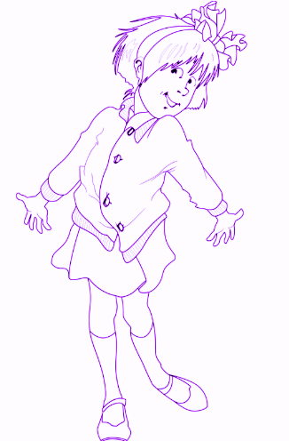 | WHY?  - Problem/Solution:
WHERE?  - Setting: | WHAT?  - Main Idea?

Compare & Contrast

Directions: Using the Venn Diagram below, compare and contrast Junie B. Jones’ feelings toward her school bus and her dad’s car.

How to use the Venn Diagram? Write the differences between the school bus and Daddy’s car in each separate circle, and write their similarities in the middle, where the two circles connect.

School Bus Daddy’s Car

My Story Notes

My Questions:

I didn’t like it when:

My favorite part was:

I laughed about:

Reflect on our reading: In the story we just read, Junie B. was very nervous and upset about riding the bus home from school. However, she felt much better at the end after she talked to her mother about it.

Directions: Write a journal entry, using complete sentences, about a time when you were upset or nervous about something and what helped you feel better.

Dear Journal,
________________________________________________________________________________________________________________________________________________________________________________________________________________________________________________________________________________________________________________________________________
_____________________________________________________________________________________________________________________________________________________________________________________________________________
_________________________________________.

Dear Parent or Guardian,

My name is Sydney Edwards, and I am a student at Averett University, majoring in elementary education. I am very passionate about introducing and encouraging children to the joy of reading books, such as the Junie B. Jones series.

This book series, written by Barbara Park, has been consistently on the New York Times bestseller list and adored by thousands of children across the globe. The main character, Junie B. Jones, is an expressive, imaginative, humorous troublemaker who learns many different lessons as she grows older throughout the series. For example, the book Junie B. Jones and the Stupid Smelly Bus informs children about the consequences of hiding from your problems, relates to their anxiety about new changes, and challenges in their lives, and makes them laugh at the funny remarks that Junie B. Jones makes throughout the story. I believe this book is a very enjoyable, educational read for your children, and as they grow up alongside Junie B. and fall in love with her character, their love for reading grows as well.

Also, the Prizery in South Boston will be producing the musical centered around this book series in the spring of 2020. This play would help bring the Junie B. Jones series to life, and it would be a great introduction to theatre.

Sincerely,

Ms. Sydney Edwards

Why I made this packet:
I hope whoever reads through this packet, realizes that I am very passionate about creatively teaching children about the joy they experience in reading books like this.

