Junie B. Jones: Toothless Wonder
Educational Resource Packet

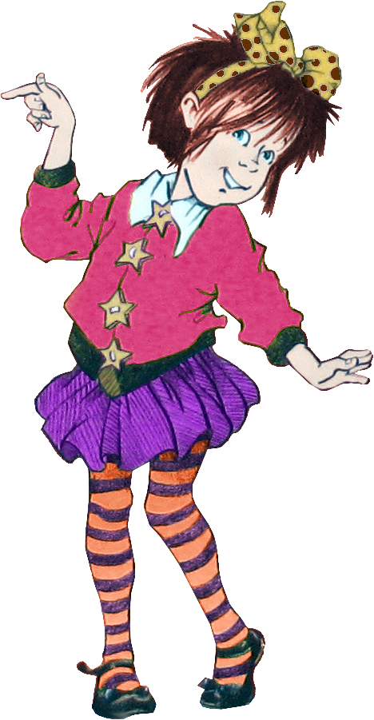

Makayla Woods
Averett University
This packet was created by a student/pre-service teacher at Averett University. It was created in fulfillment of course objectives, and its goal is to encourage reading and appreciation of the theatre. Materials created by the class are not endorsed by or affiliated with Barbara Park, the Junie B. Jones series, or its publishers.
Book Summary
In Junie B. Jones: Toothless Wonder, Junie B’s new dilemma all starts because of her loose top tooth. Junie B. soon learns that she will be the first person in first grade to lose her top tooth, which thrills her to death, until someone tells her about toothless Uncle Lou. One of her classmates has an uncle who lost all of his teeth because he did not brush, and now Junie B. thinks she’s going to look funny, just like him. With the help of Grandpa Miller, though, she learns to love her new smile. Everything was smooth sailing from there until she remembered she had to give her tooth to the tooth fairy. Junie B. refuses to leave her tooth for this suspicious tooth fairy until she knows what the tooth fairy does with all the teeth she gets from children. In true Junie B. Jones fashion, Barbara Park explores the ideas of self-esteem and the tooth fairy in a fun way to capture young readers’ attention.

A Bit about Barbara Park…
Barbara Park is the author of the New York Times bestselling series Junie B. Jones. This series of books tells of the many shenanigans of Junie B. and how she deals with the problems she faces in her everyday life. Barbara Park started writing this series in 1992 and the series has sold over 60 million copies in the United States alone. Barbara Park has also written over 50 books including the Junie B. Jones series and won more than 40 children’s book awards for her entertaining stories. She was once quoted saying, “I’ve never been sure whether Junie B.’s fans love her in spite of her imperfections or because of them but either way she’s gone out into the world and made more friends than I ever dreamed possible.” Even though Barbara Park passed away in November of 2013, the children reading her stories continue to keep her memory alive.
Learning Language Arts with Junie B. Jones
Directions: Look for the spelling, punctuation, and capitalization errors in Junie B’s journal. Circle the punctuation errors in purple, underline the capitalization errors in green, and put a blue wavy line under the spelling errors.

Dear first-grade journal,
I have big news to tell you! We know what the tooth wich does when
she picks up teeth you loose. She puts your old tooths in a babys mouth
when they are sleeping and they dont even get no moneys for it. my stinky
baby brothr ollie got my front tooth I lost the very same night. I felt it
with my own finger the next morning? I cant wait to tell Herb
about this one! I bet tattletale Mays tooth went to
some stinky baby donky that wines like she does and
This Photo by Unknown Author is licensed under CC BY
dont even know it I wonder if toothless uncle lou could
get more tooths from the fairy? ill ask Mr. scary what
he thinks about the idea. I’ve got to go now its time
for our class to go to recess and I have importent
tell the other kids for when they loose their toooths?
From,
Junie B., First Grader

She wanted to be the first kid in first grade to lose her front tooth.
Junie
B.
Jones
WANTED
SOMEBODY

STORY STRUCTURES
Junie B. Jones: Toothless Wonder
Chapters 1-4

BUT
THEN
She saw that she didn’t look like toothless Uncle Lou, and she liked her new smile.
She didn’t want to look like toothless Uncle Lou
SO…
Her tooth came out when she bit Grandpa Miller

Middle
Beginning
I can identify the ______________, ______________, & ____________ of a story.
End
This includes:

CONFLICT
CHARACTERS
RESOLUTION
SETTING
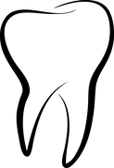
Story Structures
Junie B Jones: Toothless Wonder
Tell about the story structure in chapters 5-9, using the anchor chart made in class as an example.
Wanted
Somebody

Junie B. Jones

Then
But

So…
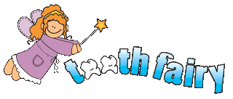
This Photo by Unknown Author is licensed under CC BY

Self-Esteem with Junie B. Jones
When Junie B. lost her tooth, she thought that she would look like toothless Uncle Lou. With the help of Grandpa Miller, she realized that she liked her new smile better anyway. Draw a picture of yourself in the box below and then write three things that you like about yourself in the blanks provided.

1) I like my ___________________________________ because_______________________________.
2) I like my __________________________________ because_______________________________.
3) I like my __________________________________ because_______________________________.
This Photo by Unknown Author is licensed under CC BY-SA
Who is the tooth fairy?
Junie B. Jones has some very important questions about this tooth fairy lady. Not only does Junie B. think the tooth fairy’s more of a witch than a fairy, but Junie also wants to know what the tooth fairy does with the teeth she takes from boys and girls. Draw a picture of what you think the tooth fairy looks like and then answer the questions below about the tooth fairy.
1) What did Junie B. think the tooth fairy did with the tooth she lost?

2) What do you think the tooth fairy does with the teeth you lose?

Show and Tell Time
In Junie B. Jones: Toothless Wonder, Junie B. wants to bring an item to school to show everyone about this big event that just happened in her life. Think about a special time in your life like a cool trip you have been on or a fun time with someone special to you. Take a picture of or draw something that reminds you of that special event and put it in the box below and then write a few sentences telling about this event. Also, be ready to explain to your classmates what it is and the awesome thing it reminds you of.

Time to brush your teeth!
Toothless Uncle Lou lost all of his teeth because he did not brush them.
Answer the questions below about how YOU brush your teeth!
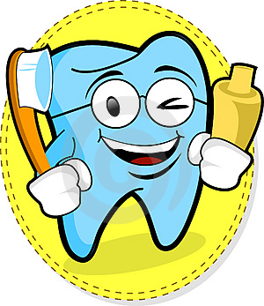
This Photo by Unknown Author is licensed under CC BY
1) How many times a day do you brush your teeth?

2) How many seconds does it take to brush your teeth?

3) What color toothbrush do you have?

4) What flavor tooth paste do you use?

How To Brush Your Teeth
Have you been brushing your teeth the right way?
This Photo by Unknown Author is licensed under CC BY-SA
First, you get out your toothbrush and run it under the water to get it wet.

Next, you get out your toothpaste and squeeze a pea sized amount onto the toothbrush.

This Photo by Unknown Author is licensed under CC BY-SA-NC
Then, you start brushing all of your teeth, front and back, inside and outside, in small circular motions for two minutes.

This Photo by Unknown Author is licensed under CC BY-SA-NC
Last, you spit out the toothpaste and rinse your mouth out with water.

This is how you should brush your teeth!

November 25, 2019
Dear Parents/Guardians,

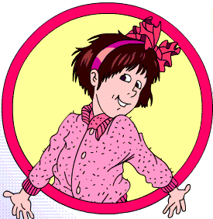
I am a pre-service teacher attending Averett University, and I am writing this letter to tell you a bit about the Junie B. Jones series that your children have been reading. This series has given quality entertainment to young readers for years with the hilarious antics of Junie B. Jones. Not only is the series entertaining, but it also offers educational benefits for your young readers. From language arts to the moral and ethical issues that are addressed based on how Junie B. sees the world, your young reader will learn these lessons hand in hand with her to help make them both better students and citizens.
This Photo by Unknown Author is licensed under CC BY-NC-ND
I also would like to tell you about an amazing educational opportunity that you and your children can share come Spring 2020. The Prizery Theatre in South Boston, VA will be doing a stage adaptation of the Junie B. Jones series. It is important to teach your children about the arts and to support your community, and this is a fun way for the entire family. The funny things Junie B. has to say and the hilarious things she does will have you laughing just like your children. I’m sure you’ll fall in love with this funny little girl just as your children have.
Best Wishes,
Ms. Woods
Averett University

This Photo by Unknown Author is licensed under CC BY-SA-NC

Hopefully this resource packet will be a help to you as you inspire learning among your young readers. Just a reminder, don’t forget the Prizery Theatre in South Boston will be putting on the stage adaptation of Junie B. Jones: The Musical in the Spring of 2020. Come out and experience this entertaining series brought to life.

Best Wishes,
Makayla Woods
Averett University

