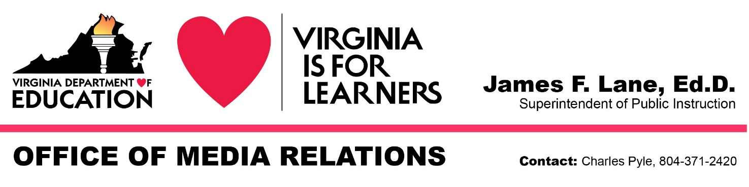
For Immediate Release: October 8, 2020

Franklin County Teacher Named

2021 Virginia Teacher of the Year

RICHMOND — Anthony Swann, a fifth-grade teacher at Rocky Mount Elementary in Franklin County, was named 2021 Virginia Teacher of the Year this evening during a virtual recognition ceremony livestreamed on social media. Swann was selected from the eight regional winners announced last month and is now the commonwealth’s nominee for 2021 National Teacher of the Year.

Superintendent of Public Instruction James Lane made the announcement at the conclusion of the ceremony, which included remarks from Governor Ralph Northam, first lady Pamela Northam, Secretary of Education Atif Qarni and state Board of Education President Daniel Gecker.

“First of all, I’d like to thank God for the opportunity to serve his children. It’s been a dream of mine ever since I was 11 years old. Words cannot express how humbled and grateful I am to have this honor,” Swann said. "I plan to utilize this opportunity to give hope to those students who feel that their current trauma or economic hardship is the end of their world. Teachers, together we have the ability to change one life at a time through our influence. Let’s continue to change the world, one child at a time.”

“While tonight’s Virginia Teacher of the Year ceremony was virtual because of the coronavirus pandemic, Anthony Swann is the real deal,” Lane said. “He represents the thousands of Virginia teachers who dedicate every day — whether teaching remotely or in person — to the academic success of their students and their social and emotional well-being. Anthony overcame many challenges to get where he is today, and he shares those life lessons with his students as he prepares them for success in the classroom and beyond.”

"As a former classroom teacher, I know the commitment it takes to create compassionate classrooms and teach in a way that incites curiosity and inspires students to become lifelong learners," Qarni said. "Anthony's commitment to inspiring students is clear in the way he goes above and beyond to mentor students both inside and outside the classroom, and I am proud to celebrate Anthony as Virginia's Teacher of the Year."

Swann, the Region 6 Teacher of the Year, was named Virginia’s top teacher after being interviewed last week by a committee that included representatives of professional and educational associations and the business community.

Swann began his teaching career in 2007 at Schoolfield Elementary in Danville. From 2013-2015, he taught at Stoney Creek Elementary in Caswell, North Carolina. Swann returned to Virginia in 2015, teaching at Johnson Elementary in Danville for two years before assuming his current position at Rock Mount Elementary in 2017.

(more)

In addition to teaching all subjects, Swann provides mentoring and life-skills coaching for fifth-grade boys through the Guys with Ties program he started at Rocky Mount Elementary in 2019. The program includes lessons on the importance of integrity, honesty and respect. The students are required to “dress to impress” twice a month and participate in 45-minute lessons. Swann also schedules guest motivational speakers several times a year.

Swann also helped develop Rocky Mount Elementary’s Cooperative Culture Initiative. The program rewards students for positive behavior and achievement and is credited with improving school culture and reducing disciplinary referrals.

Swann earned a Bachelor of Science degree in Elementary Education from Averett University in 2007 and a Master of Education in Educational Leadership from Regent University in 2014. Swann has taught elementary school for 13 years.

As the 2021 Virginia Teacher of the Year, Swann received monetary awards from Dominion Energy Services Inc., Allen, Allen, Allen & Allen and other sponsors. He also received a membership to the Virginia Museum of Fine Arts, educational opportunities from many public and private colleges and universities, tickets to Kings Dominion, a gift from Virginia State University, an engraved plaque from Bunkie Trinite Trophies Inc., and an engraved crystal apple.

Other sponsors of the Virginia Teacher of the Year Program include the Virginia Lottery, Virginia School Boards Association, Wells Fargo Bank NA, Association of Teacher Educators in Virginia, Moseley Architects, Virginia Association of Colleges for Teacher Education, Virginia Education Association, Virginia529, Kroger and Capital Interior Contractors Inc.

The other seven 2021 Virginia Regional Teachers of the Year — who were also honored during the ceremony — are as follows:
- Sarah F. Jurewicz, a Culinary Arts I and II (Baking and Pastry Arts) teacher at the Chesterfield Career and Technical Center in Chesterfield County (Region 1)
- Alisa T. Smith, a Spanish teacher at Jamestown High in Williamsburg-James City County (Region 2)
- Kimberly G. Cannon, a U.S. History teacher at Stafford Middle in Stafford County (Region 3)
- Lisa M. Rode, a sixth-grade teacher at Kings Glen Elementary in Fairfax County (Region 4)
- Lisa S. Cooper, a first-grade teacher at Bessie Weller Elementary in Staunton (Region 5)
- Sarah M. Biggs, a first- and second-grade reading teacher at High Point Elementary in Washington County (Region 7)
- Victoria S. Soyars, a Geometry teacher at Park View High in Mecklenburg County (Region 8)

Biographies of Swann and the other seven 2021 Virginia Regional Teachers of the Year are available in the program for tonight’s ceremony.

VPM will broadcast a recording of tonight’s Virginia Teacher of the Year ceremony on Sunday, October 11 at 12 p.m., and at 5:30 p.m. on VPM+. A video of the ceremony is also available on the VDOE YouTube channel.

The 2021 National Teacher of the Year will be announced next spring at a White House ceremony. Three previous Virginia teachers — Mary V. Bicouvaris, the 1989 Virginia Teacher of the Year; B. Philip Bigler, the 1998 Virginia Teacher of the Year; and Rodney A. Robinson, the 2019 Virginia Teacher of the Year — went on to be named National Teachers of the Year.

# # #

