Averett University Screening Registration Instructions
Onsite screening details
Date/Time: November 5th, 7am-11am
Location: 351 Townes Street, Carrington Gym
Appointment duration: Please plan for 20-25 minutes for your screening
Screening testing provided: height, weight, BMI, waist, blood pressure, total cholesterol, HDL, cholesterol ratio, LDL, triglycerides, glucose
Testing will be conducted via fingerstick. Fasting is recommended but not required.
Registration Instructions
- Register or Log into the WebMD Portal at https://webmdhealth.com/VPC/
- Click on the Biometric Screening Service Card.

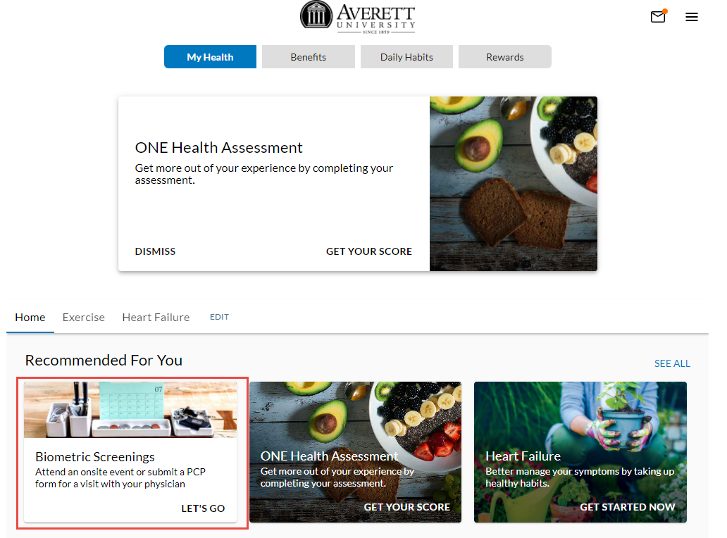
- Select the “Register for Onsite Screening” on the Screening Landing Page
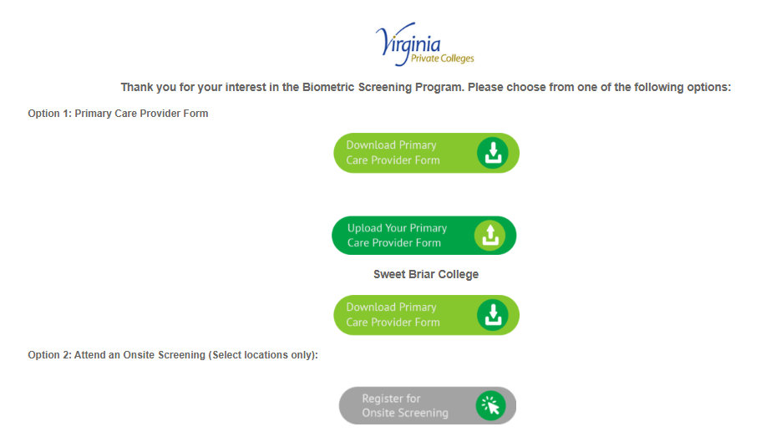

- Click the “Register” button next to the Averett University event
Note: You do not need to click the “sign in” button unless you need to cancel or reschedule your screening appointment.
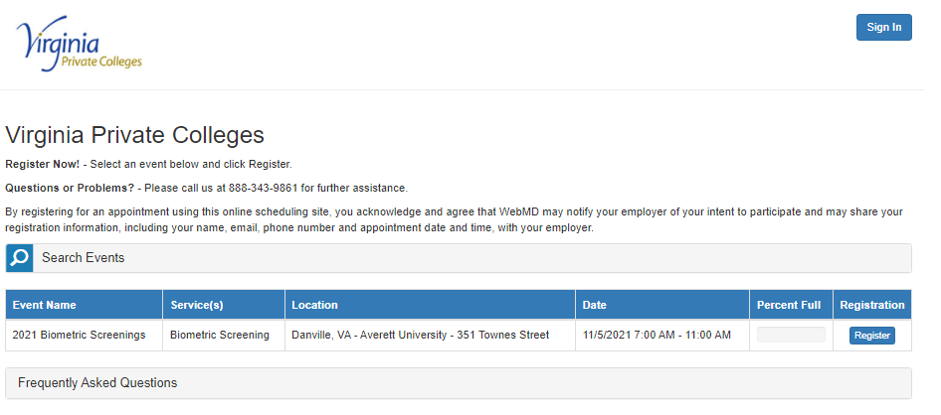

- Select your desired appointment time and complete the Registrant Information and click “Register” at the bottom of the page.

You will receive a confirmation email and 2 reminder emails prior to your scheduled appointment

