Junie B Jones Education Resource Packet
By Trevor Mensavage

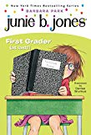
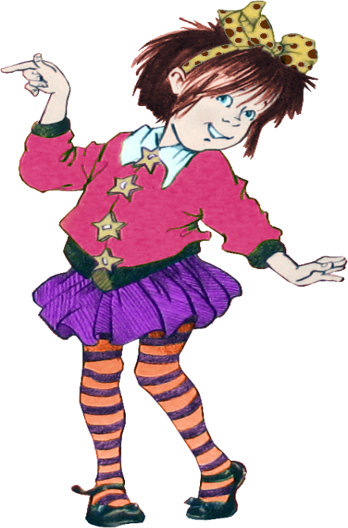
This Photo by Unknown Author is licensed under CC BY-NC-ND
This Photo by Unknown Author is licensed under CC BY

This packet was created by a student/pre-service teacher at Averett University. It was created in fulfillment of course objectives, and its goal is to encourage reading and appreciation of the theatre. Materials created by the class are not endorsed by or affiliated with Barbara Park, the Junie B. Jones series, or its publishers.

This educational resource packet was created based off of the children’s book Junie B. Jones: First Grader at Last. In this story, Junie B. is very nervous about the start of her first-grade year. She finds out her old friends have made new friends and gives her new teacher the classic nickname “Mr. Scary.” Her school year takes another twist when she finds out she needs to wear glasses. At first, Junie B. is ashamed of her new glasses, but after showing the courage to bring them to show and tell, she finally can see that her friends never left, and the rest of the year became “crystal clear”.

Junie B. Jones: First Grader at Last was written by Barbara Park. Barbara Park was a mother of two, married to Richard Park, and lived out her adult years in Arizona. Her initial plan was to become a high school history teacher, but her heart always drove her towards writing. Her best-selling series is the Junie B. Jones series. It sold 60 million copies worldwide and was a fan favorite for a full two decades and beyond. Her journey ended when she died of ovarian cancer after a seven-year long fight. During this battle, she was very charitable and spent lots of time raising awareness in support of other ovarian cancer survivors. She passed away on Friday, November 15, 2013.

Junie B Jones: First Grader at Last Reading Guide

Who is the main character?
_____________________________________________________________________________
What is happening in beginning of the story? __________________________________________________________________________________________________________________________________________________________
How does the character feel? __________________________________________________________________________________________________________________________________________________________
Why does she feel like this? __________________________________________________________________________________________________________________________________________________________
_____________________________________________________________________________
What happens in the middle of the story? ____________________________________________________________________________________________________________________________________________________________________________________________________________________________________________________________________________________________________________________
How does this make the character feel? __________________________________________________________________________________________________________________________________________________________
What happens at the end of the story?
__________________________________________________________________________________________________________________________________________________________
How does the character feel at the end of the story?
__________________________________________________________________________________________________________________________________________________________
What did the character learn?
__________________________________________________________________________________________________________________________________________________________
This Photo by Unknown Author is licensed under CC BY

This Photo by Unknown Author is licensed under CC BY-SA

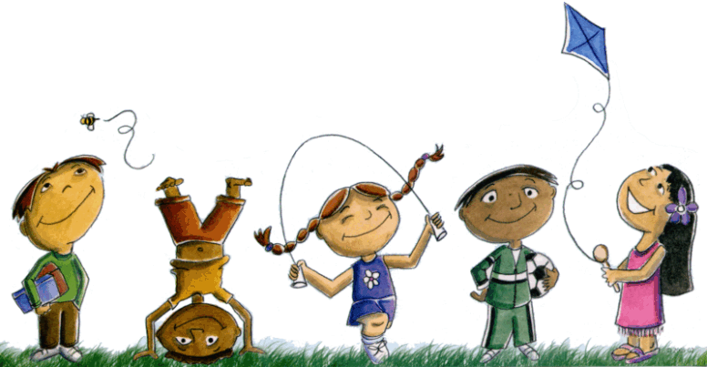
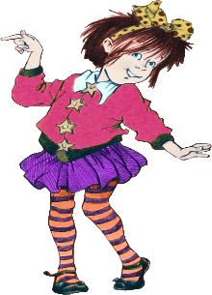
Who are the main characters in Where did this book take
This Photo by Unknown Author is licensed under CC BY-NC-ND
This Photo by Unknown Author is licensed under CC BY-NC-ND
This Photo by Unknown Author is licensed under CC BY
What is the main problem in the book?
Junie B Jones: First Grader at Last? place?

How was the problem solved?

In Junie B Jones: First Grader at Last, Junie learned to wear her glasses with confidence!

Are you confident about how well you play a game or sport? Or are you confident about your grades in school? What are YOU confident about?
________________________________________________________________________
________________________________________________________________________
________________________________________________________________________
________________________________________________________________________
Why is it important to be confident in yourself?
________________________________________________________________________
________________________________________________________________________
________________________________________________________________________
________________________________________________________________________
Can you affect someone else’s confidence? How?
________________________________________________________________________
________________________________________________________________________
________________________________________________________________________
________________________________________________________________________

Junie B. Jones Journal Entry

Please correct all the following mistakes in the journal entry.
Circle the spelling errors in red.
Underline the punctuation errors in yellow.

Tuesday
Dear first grade journal,
Mr. Scary just called me in from reecess. All the other children are still playing out their. He said for me too write in my journal, for a minite and he will be, with me soon. I keep peeking at him from behind, these pages. He is printing sentences on the board. It is extra work for me I think. I do not actually aprove of this.
From, Junie B., First Grader

SHOW AND TELL

When her class has a show and tell, Junie B Jones brings in her new glasses to show her friends.
What would YOU bring if this class had a show and tell? Why do you want to show it to everyone?
________________________________________________________________________________________________________________________________________________________________________________________________________________________________________________________________________________________________________________________________________________________________________________________________________________________________________________________________________________________________________________________________________________________
Draw a picture of you would bring to class!

Dear Parents and/or Guardians:

My name is Trevor Mensavage, and as a pres-ervice teacher, I have been researching different methods used to teach comprehension skills and build character simultaneously. The Junie B. Jones series, created by Barbara Park, provides relatable content for elementary school students that simultaneously incorporates entertainment, education, and good values. The perspective Park captures with her character, Junie B., enables younger readers to conceptualize the idea of a character and plot because they can relate to the events in the book. The research I found suggests that students academically thrive when they are given the opportunity to interact with a story and connect the characters in the novel to their own attitudes and perspectives.
This story explored the values of self-confidence and courage, and it also addressed the nerves that come with beginning a new school year. Junie experiences actual feelings first graders may feel themselves. My educational resource packet includes a reading guide, an exercise on self- confidence, a grammar exercise, and two fun activities that the students can work together to complete.
The performance of Junie B Jones: The Musical at The Prizery would be a very effective way to inspire your child to take interest in theatre, or at least inspire them in their educational future. The experience of a live show will most definitely leave an impression on them that leads them to success. The number of opportunities children come across to see such a recognizable and relatable character on stage is considerably low, and it is this kind of culture that can light a fire in a student’s mind and drive them to want to learn ,and this is the goal every teacher strives to accomplish.
Trevor Mensavage

