African & African American Studies

Fall 2020 Course Offerings





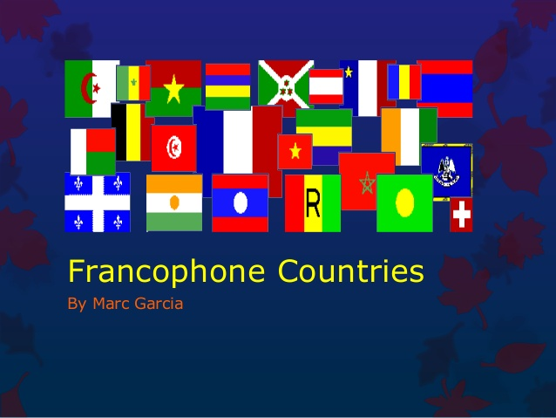

An interdisciplinary minor in African and African American Studies calls upon the strengths of our faculty and the interests of our students.

Requirements: 18 semester hours (1 core class + 5 electives at designated levels) in any discipline that meets the content-specific nature of the program; previously completed courses that meet the criteria could count towards the minor. \*Note: To declare a minor, you must complete paperwork in the Registrar’s office.

Speak to or email Ms. Gazda for details (agazda@averett.edu)

Ask your advisor for details, then register for any of the following courses:

* ENG/AFAM 242 – African American Literature (Gazda, TTh: 8:00-9:25 am)
* HIS/AFAM 399 – The American South (Canady, TTh: 9:40-11:05 am)
* FR/AFAM/WGS 313 – Francophone Women Writers (Clark, MWF: 1:50-2:45 pm)
* ENG/AFAM 439 – Literary Criticism, Analysis & Interpretation (Gazda, TTh: 9:40-11:05 am)
* ENG/AFAM 414 – Shakespeare (Wuest, TTh: 1:00-2:25 pm)