Elizabeth Dinkle
December 6, 2019
Education Resource Packet
Junie B. Jones and that Meanie Jim’s Birthday
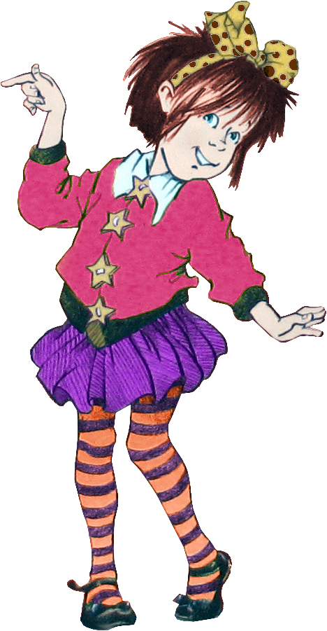
This Photo by Unknown Author is licensed under CC BY
This packet was created by a student/pre-service teacher at Averett University. It was created in fulfillment of course objectives, and its goal is to encourage reading and appreciation of the theatre. Materials created by the class are not endorsed by or affiliated with Barbara Park, the Junie B. Jones series, or its publishers.

Plot Summary
Book: Junie B. Jones and that Meanie Jim’s Birthday
Junie B. Jones is a kindergarten student in Room Nine. A classmate of Junie B.’s is having a party in the class. On the way home, Grace and Junie B. are talking about their birthdays. Jim interrupts them to say that he is having his party on Saturday and he is inviting everyone but Junie B. This hurts her feelings. She decides that she wants to move her birthday to get revenge on Jim. Jim eventually ends up giving Junie B. an invitation to the party when they are both in the Principal’s office. In the end, Junie B. decides to help Grandpa Miller fix the toilet instead of going to the party.

“About the Author” Note

Barbara Park is the author of the Junie B. Jones book series. She was born on April 21, 1947, in Mount Holley, New Jersey. However, as an adult, she lived most of her life in Arizona. Before she decided to be a writer, she wanted to teach history and political science to high schoolers. She had several rejections in the beginning of her writing career. She went on to write over 50 books on several levels (middle school books, children’s books, and picture books). She won several Children’s Choice Awards. She also started a charity for people with ovarian cancer to help with their financial needs. She passed away November 15, 2013 from ovarian cancer after fighting it for seven and a half years.

TEACHER DIRECTIONS FOR ALL ACTIVITIES

Activity #1 – Grammar/ Language
This is a pre-reading activity. In the novel, Junie B. Jones gets very mad when she is not invited to Jim’s birthday party. He invited each child in the class to come to his part except her. She wanted to move her birthday party closer to his so that she could invite everyone in her class except him.
The students could also write a small paragraph about their ideal birthday party and draw a picture of them with their friends at the party.

Activity #2 – Moral Activity
When Junie B. Jones does not get invited to the party, she gets very angry. The teacher and students could talk about the emotion of anger and times where they have felt angry.
Then, the students will write a small journal entry about a time that they were angry and ways to deal with that anger.

Activity #3 – Literary Concern
This activity focuses on the plot of the book. The teachers and students will create a timeline of the Junie B. Jones book together.

Activity #4- Literary Concern
This is a readers theatre exercise. The students will be divided into groups.
Each group is responsible for a chapter in the novel. Each group of students will act out their chapter in the order of the events in the book to recreate the plot of the story.

Activity #5 – Literary Concern Activity
Junie B. Jones Character Sheets. The teacher can introduce the topic of character traits.
The directions for the students would be to list words that describe the main character (Junie B. Jones). The students will have to draw Junie B. Jones based on the words they have listed.

Activity #6 – Theme Activity
This exercise focuses on one of the major themes of the book–kindness. It is important for the students to realize that they need to be kind to everyone all the time. The students will write down ways that they show kindness.

ACTIVITY #1
Name:_____________________________ Date: ____________________________
Directions: Junie B. Jones was very upset when she was not invited to Jim’s birthday party. She decides to move up her own birthday party. Think about your own perfect birthday party.

Drawing
Draw a picture of you and your friends at your party. Color your picture.

Writing
Write five sentences about your perfect birthday party.

______________________________________________________________________________________________________________________________________________________________________________________________________________________________________________________________________________________________________________________________________________________________________________________________________

ACTIVITY #2
Name: _________________________ Date: __________________________

Directions: In Junie B. Jones and that Meanie Jim’s Birthday, Junie B. feels angry when she does not get invited to the birthday party for Jim.

How would it make you feel not to be invited to a party? Write a journal entry about a time that you felt angry, sad, or upset. Describe things that made you feel better.

________________________________________________________________________________________________________________________________________________________________________________________________________________________________________________________________________________________________________________________________________________________________________________________________________________________________________________________________________________________________________________________________________________________________________________________________________________________________________________________________________________________________________________________________________________
Author is licensed under CC BY-NC-ND

ACTIVITY #3

Name: ________________________________ Date: _________________________

Directions: As a class, we will put together a timeline of our Junie B. Jones book.

Vocabulary:
Timeline - the specific order of events.

CLIMAX – the major event and possible turning point of the story and it goes in the center of the timeline.
Timeline Characteristics:
- Start on the left side of the page
- Climax goes in the center of the timeline
- End of the timeline is on the right side
Specific Timeline Events:
1. Paulie Allen Puffer’s birthday party in Room Nine (left side)
2. Junie B. finally gets invited to Jim’s birthday party (climax)
3. Junie B. helps Grandpa Miller fix the toilet instead of going to Jim’s birthday party (right side)
* Fill in the rest of the key events*

____________________________________________________________________________

ACTIVITY #4
Name: _______________________________ Date: ___________________________
Directions: In your group, you will be assigned a chapter of the novel to act out for the class. These chapters will be acted out in the order of the novel. This is a note sheet for your group.
This Photo by Unknown Author is licensed under CC BY-NC-ND
1. Who is in your group? ____________________________________________________________________________________________________________________________________________________________2. What is the name of the novel? ______________________________________________________________________________3. What chapter were you assigned from the novel? _________________________________
4. Summarize your assigned chapter: __________________________________________________________________________________________________________________________________________________________________________________________________________________________________________5. Extra notes: ____________________________________________________________________________________________________________________________________________________________
ACTIVITY #5

Name: ________________________________ Date: _________________________

Directions: Junie B. Jones is a character who is very relatable based on her personality.

Character Traits of Junie B. Jones
List words that describe Junie B. Jones
1. _____________________________________________________________
2.______________________________________________________________
3. ______________________________________________________________
4. ______________________________________________________________
5. ______________________________________________________________
Drawing of Junie B. Jones
Draw a picture of Junie B. Jones based on the character traits you used to describe her.

ACTIVITY #6
Activity #6
Name: _______________________________ Date: _____________________________
Directions: Kindness is a major theme in Junie B. Jones and that Meanie Jim’s Birthday. Kindness is not always seen in this novel. Jim does not want to invite Junie B. to his party. He eventually gives her an invitation and she is happy. It takes a strong act of kindness on Jim’s part to do this.
How do you show kindness? Write on the lines below ways that you show kindness.
❤
1. ___________________________________________________________________
2. ___________________________________________________________________
3. ___________________________________________________________________
4. ___________________________________________________________________
5. ___________________________________________________________________
6. ___________________________________________________________________
7. ___________________________________________________________________
8. ___________________________________________________________________
9. ___________________________________________________________________
10. __________________________________________________________________

Dear Parents and/or Guardians,
My name is Elizabeth Dinkle. I am a pre-service teacher from Averett University. I graduate with a teaching license in PreK-6th grade in May 2020.
The Junie B. Jones book series that keeps children constantly laughing was written by Barbara Park. This series was a consistent #1 New York Times Best Seller and has sold over 60 million copies in just North America. This book series can be found in classrooms all over the world.
I am writing you this letter to inform you of the Spring 2020 production of Junie B. Jones: The Musical at The Prizery in South Boston, Virginia. This play offers both entertainment and educational value for your children. It teaches them to be kind to others. Junie B. Jones is also an entertaining character. For example, Junie B. turns Meanie Jim’s “big fatty head” around when he makes fun of her getting in trouble.
This theatrical performance will be very worthwhile for students of any age. It will allow them to see a familiar book in action. They will also get a real life visual of a text that they know very well. This is a book that is on their level, and they can learn from the different themes of the book and apply them to their daily life. This musical will keep the whole family laughing! We hope to see you all at The Prizery for the Spring 2020 production of Junie B. Jones: The Musical. Thank you!

Sincerely,
Elizabeth Dinkle

This Photo by Unknown Author is licensed under CC BY
We hope to see all you at The Prizery’s Spring 2020 Production of
Junie B. Jones: The Musical.
Thank you!
Sincerely,
Elizabeth Dinkle

