Junie B. Jones Has a Monster Under Her Bed
Abigail J. Taylor
Averett University

This packet was created by a student/pre-service teacher at Averett University. It was created in fulfillment of course objectives, and its goal is to encourage reading and appreciation of the theatre. Materials created by the class are not endorsed by or affiliated with Barbara Park, the Junie B. Jones series, or its publishers.

Junie B. Jones Has a Monster Under Her Bed
Plot Summary

The book Junie B. Jones Has a Monster Under Her Bed is about a young girl dealing with the fear that she has a monster under her own bed. As the story begins with Junie B. Jones having a normal day at school, it turns around quickly due to the fact that one of her classmates tells her that everyone has a creature living under their bed. Junie B. Jones goes through the rest of the book learning how to overcome her fears, with her family supporting her every step of the way. I believe this particular story is great for young children to read because they can relate with having fears they need to overcome as well. By the end, Junie B. Jones realizes that there are no such things as monsters that live under her bed and continues on having a fearless and carefree life.
About the Author
Although Barbara Park is most known for her Junie B. Jones series, she is also famous for writing other books in her career such as The Kid in the Red Jacket, and The Graduation of Jake Moon. The Junie B. Jones series was a consistent #1 bestseller in the New York Times for over 180 weeks in a row and still continues to be considered an all-time favorite for many young readers. Barbara Park’s passion was so beautiful and has made kids across the globe learn different life lessons throughout every Junie B. Jones book they read. Even though she passed away in November of 2013, Barbara Park’s soul still lives on inside of each one of her books that was written and still makes millions of children happy every year.

Junie B. Jones
Has a Monster Under Her Bed
Activity
The book we read for this activity covers many different fears. Just as Junie B. Jones had a fear of monsters under her bed, we may all have our own fears. Use this exercise to express those feelings.

- Junie B. Jones was scared of the thought that there was a monster under her bed. What do you think a monster would look like? Draw it.

- Do you remember a time where you were scared? Write about it.

- If you have any fears, how do you deal with them?

Junie B. Jones
Nouns Activity
- What is a noun?
- Action word
- Describing word
- Person, place, or thing

2.) Circle the nouns in the sentence below:

Junie B. Jones thought there was a monster under her bed.

3.) The word “Monster” is a:
- Person
- Place
- Thing

4.) Write three nouns that name a place:

5.) Write three nouns that name a person:

6.) Write three nouns that name a thing:

MY FAVORITE CHARACTER

My favorite character in
Junie B. Jones Has a Monster
Under Her Bed is:
Draw your favorite character:

List 4 details about your
favorite character:

I liked this character because:
MY JUNIE B. JONES
STORY NOTES

I laughed at:
My Favorite Part about the book was:

What made me sad:
I was surprised about:

Trapping a Monster
How would you trap a monster living under your bed? What tools, traps, and other items might you use trying to trap your monster?

__________________________________________________
__________________________________________________
__________________________________________________
__________________________________________________
__________________________________________________
__________________________________________________
__________________________________________________
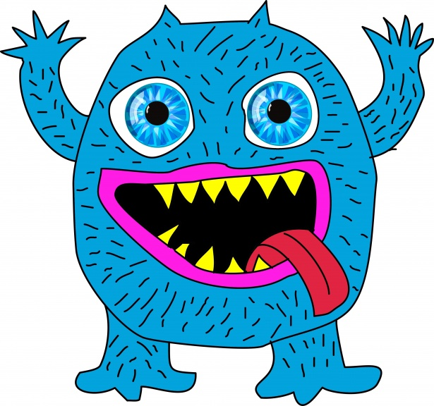
__________________________________________________

Junie B. Jones Has a Monster Under Her Bed
Story Setting
Setting: where and when a story takes place.
Where is Junie B. Jones Has a Monster Under Her Bed set?
__________________________________________________

Imagine that you are Junie B. Jones and you are in the story setting right now…
What can you see?
__________________________________________________

What can you hear?
__________________________________________________

What can you touch?
__________________________________________________

What can you smell?
__________________________________________________
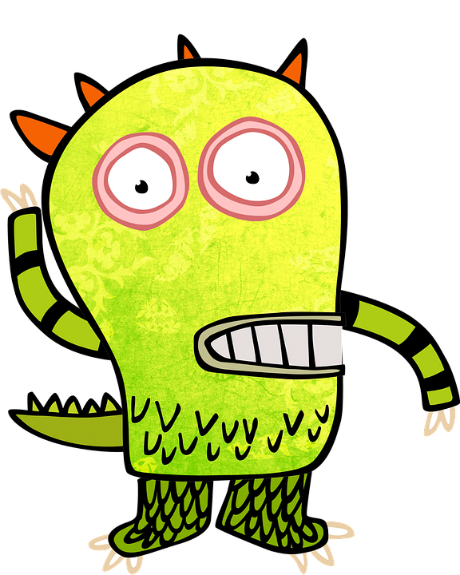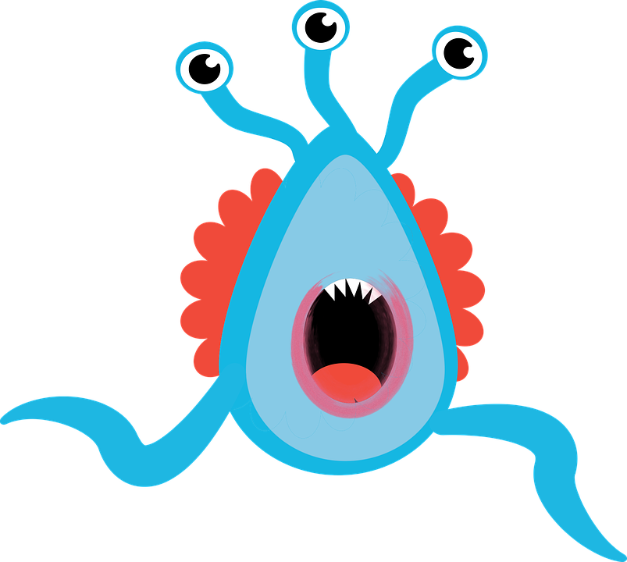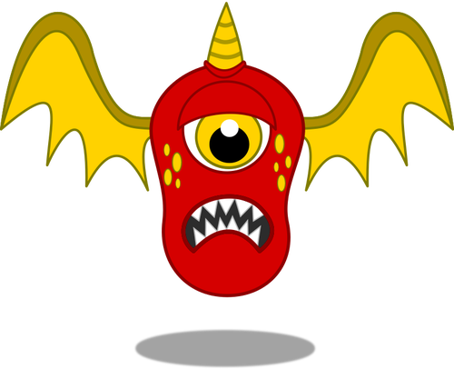
Dear Parents and/or Guardians,
My name is Abigail Taylor, and I am a senior at Averett University studying Biological Psychology. As I plan on continuing my education after Averett to get my Masters in nutrition, I am also working towards my English minor. I am excited to have the chance to expand the minds of young children through this reading and help them learn the many different lessons that lie in literature.
Throughout these exercises, I have used my psychology background to take a look into the minds of your child and use critical thinking with activities based on the series. There will also be a chance for your child to experience a show called Junie B. Jones: The Musical, which will be held at The Prizery in South Boston early next year. This show can also introduce young kids to the beauty of theatre and assist them with a better understanding of the Junie B. Jones Series. I hope that experience and these exercises are valuable to you!

Sincerely,
Abby Taylor

Thank you

