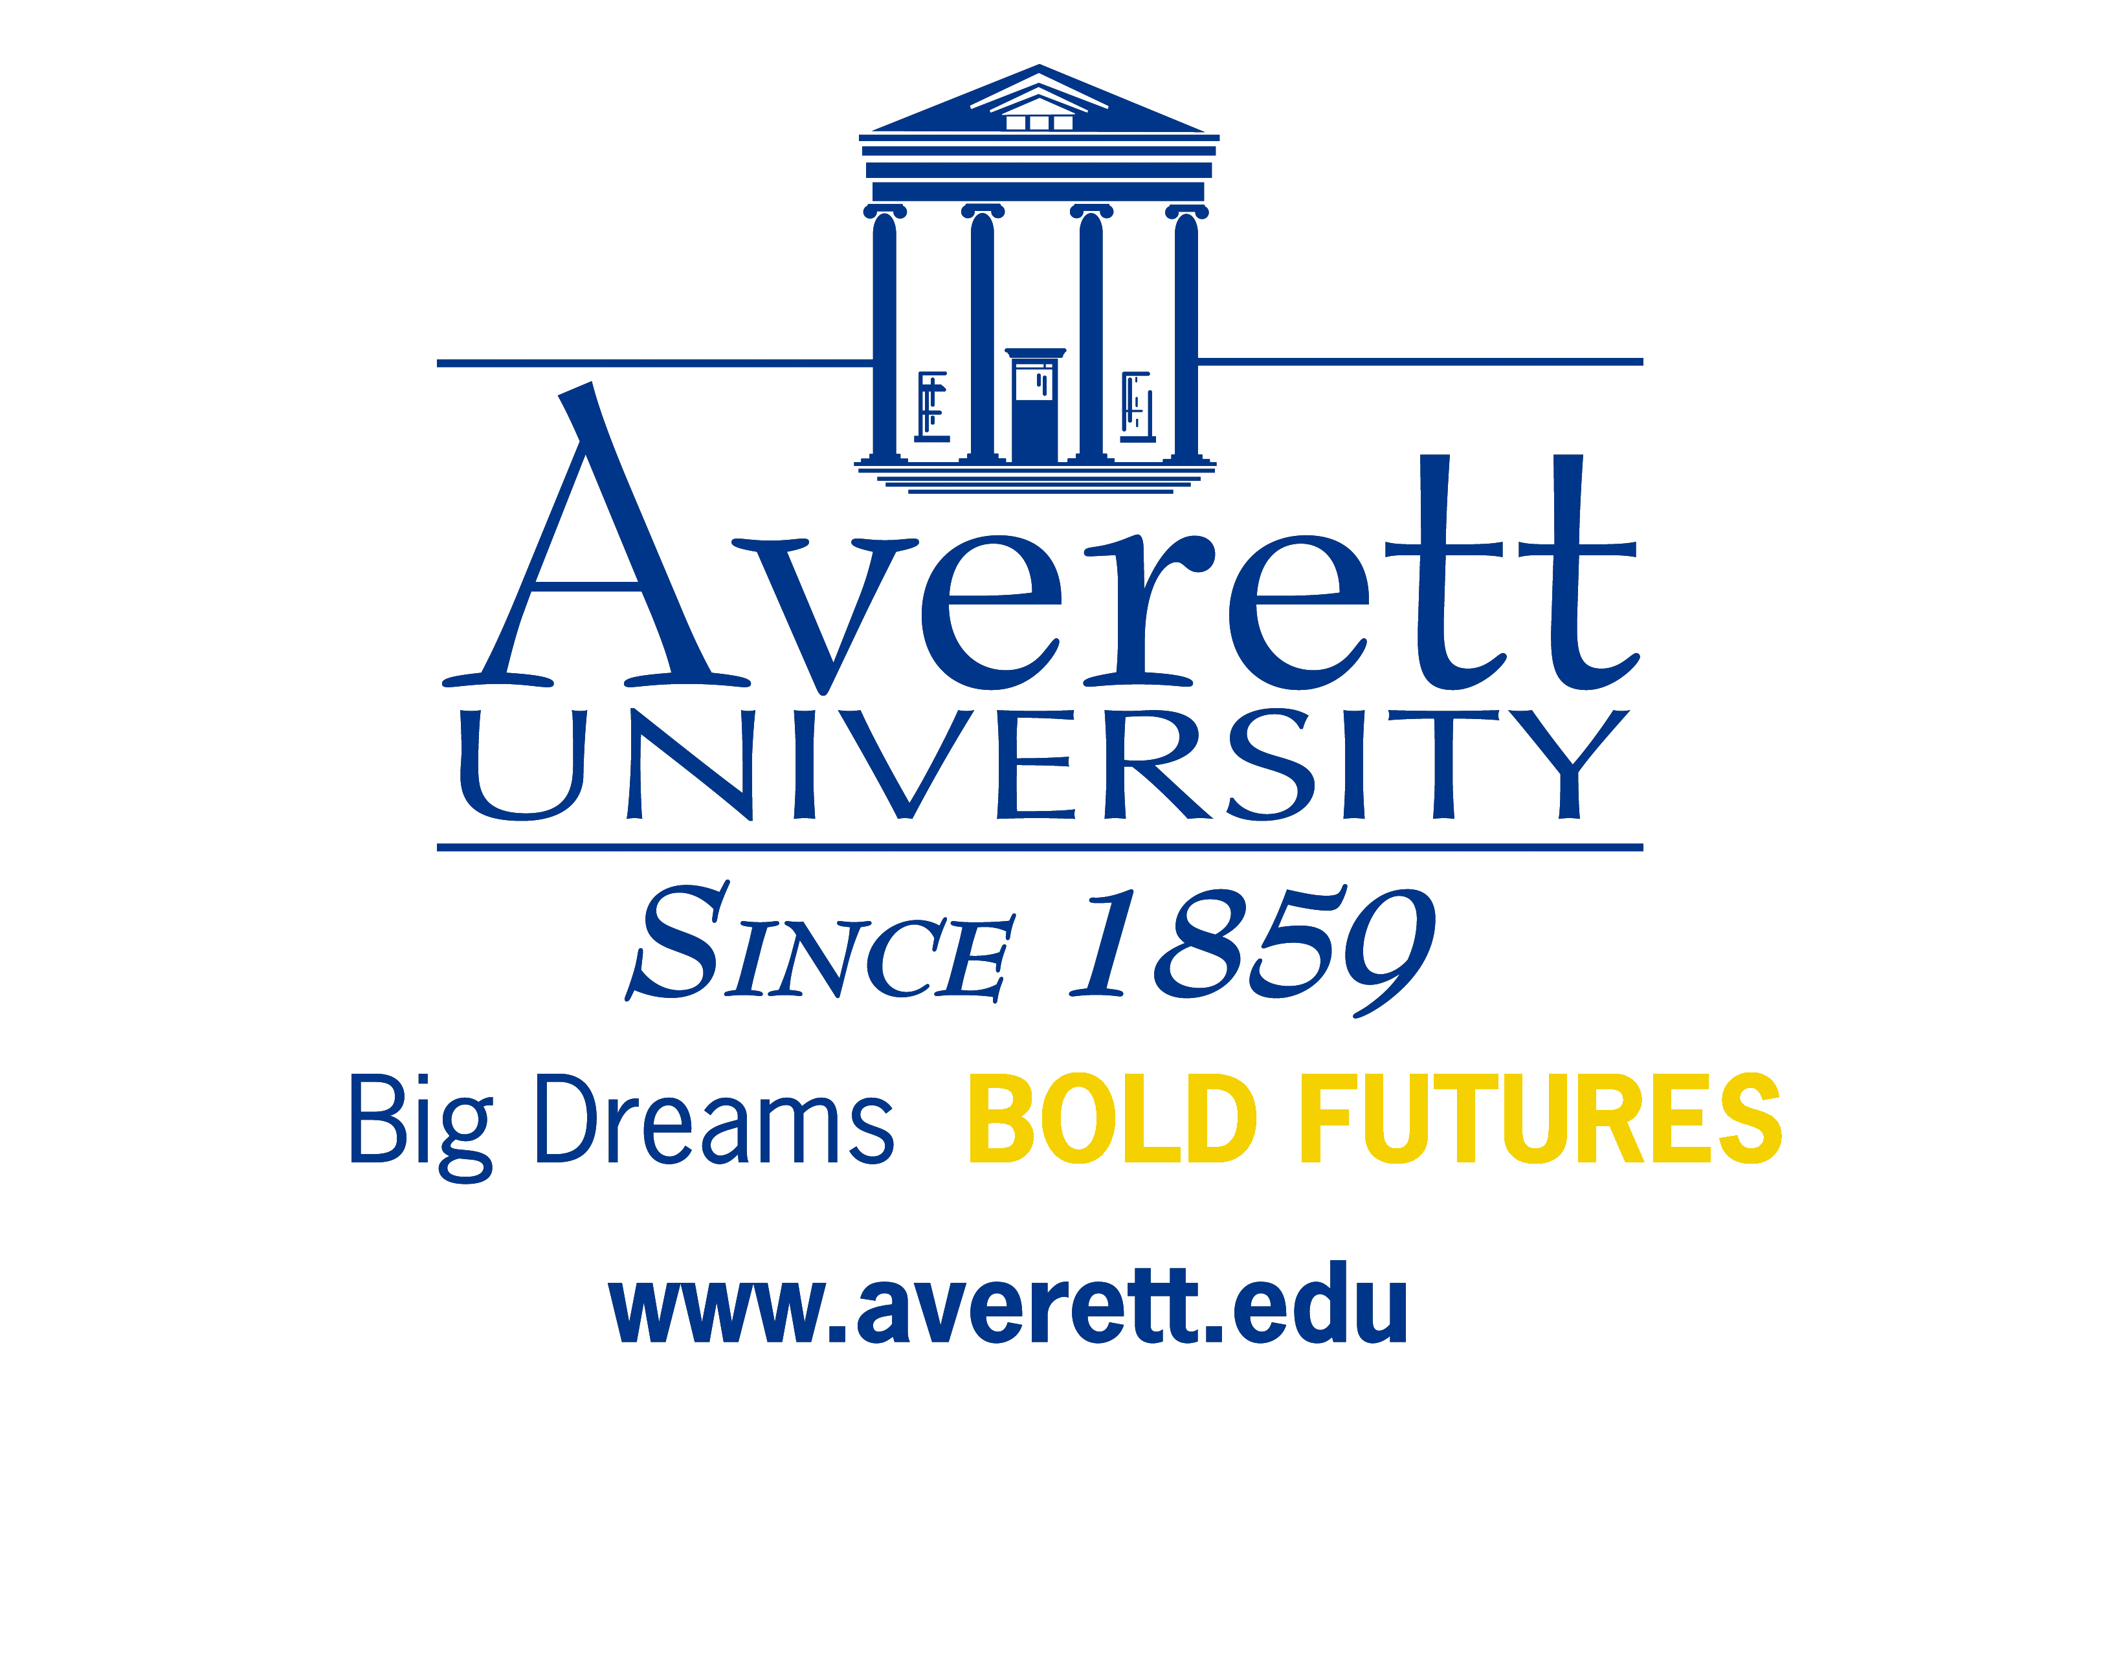
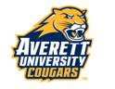
2013-2014
AVERETT UNIVERSITY
Federal Direct Parent PLUS PreApproval
Student Information

Student’s Last Name First Name Middle Initial Social Security Number

Student’s Date of Birth

Parent Information

Parent’s Last Name First Name Middle Initial Social Security Number

Parent’s Permanent Street Address Parent’s Date of Birth

Parent’s City State Zip Code Parent’s Home Phone Number

Parent’s e-mail address Parent’s Day Time Phone Number

I, the parent borrower, request $ in a Federal Direct PLUS Loan to be utilized during the following Loan Period: Fall 2013/Spring 2014 Fall 2013 only Spring 2014 only

I am: a U. S. Citizen an eligible Non-Citizen My Alien Registration No. is:

I am in default on a federal education loan and/or owe a repayment on a federal education grant.
No Yes (If you answer yes, you do not meet eligibility requirements to receive a Federal Direct PLUS Loan.)

My relationship to the student: Natural/Adoptive Parent Step-parent (my tax data is provided on the FAFSA)

I provide my permission for the Federal Direct PLUS Loan funds to be used to pay any outstanding university charges in additional to direct costs, such as tuition, fees, housing, etc. Yes No

After the Federal Direct PLUS Loan has been applied to the student’s outstanding charges, I request any excess to be refunded: to the student to be mailed to me at my address listed above

I consent that a representative from the Averett University Office of Financial Aid may run a credit check through the U.S. Department of Education. I consent to the U.S. Department of Education and its agents obtaining a report of my credit record and using the information from that report in determining whether to make a Direct PLUS Loan to me. I understand that I will be notified in writing of the results of the credit check with respect to my loan application. The information I have provided above is true and complete to the best of my knowledge.

NOTE: Pre-approvals are valid for 180 days. Loan applications received more than 180 days from the pre-approval date will need to be re-qualified.

I understand that my request for credit approval does not guarantee eligibility for a Federal PLUS loan nor does it qualify as a complete application for a PLUS loan.

Please complete this form, print, parents sign, date, and return to the Student Financial Services Office @ Averett University or fax 434-791-5647.

_____________________________________________________ __________________
Signature of Parent PLUS Loan Applicant Date
Averett University ▪ Student Financial Services ▪ 420 West Main Street ▪ Danville, VA 24541 ▪ 1-800-283-7388 ▪ Fax: 434-791-5647 ▪ finaid@averett.edu
sfs 02/04/2013

