Accessing “SmarThinking” (online tutoring) through Moodle
- Open Internet Explorer as your web browser, and go to this link to login:
  - https://moodle.averett.edu/login/
- Using your Averett login information, type in your username and password.
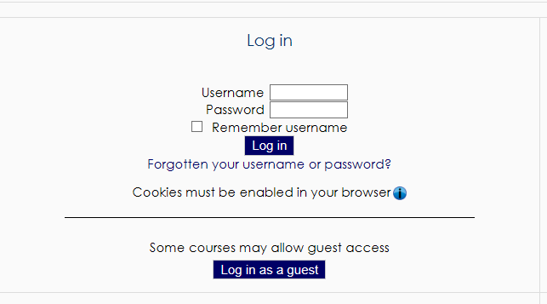
- Look on the side of the screen under “Navigation” and click “Site home.”
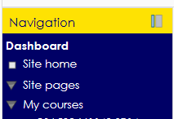
- Scroll to the bottom of the webpage. Type in the search box the word “SmarThinking,” and hit the “Enter” key on your keyboard (remember that SmarThinking only has 1 “t”).
- The word “SmarThinking” will appear highlighted. Click on the highlighted word.
- A green puzzle piece with the words “SmarThinking Online Tutoring” should appear on the welcome screen. Click on the hyperlink (make sure you have pop-ups enabled).
- You will then be at the welcome screen and can choose to:
  - Work with a tutor -- Immediate one-on-one tutoring through chat
  - Submit a question -- Send in a question and receive a response within 24-48 hours
  - Submit writing -- Submit a paper for review (it will be returned within 24-72 hours)
    - Do not use this option if you have a paper due the next day!

